Paper 1: Kittichaiwattana et al. - Facial Expression Recognition Using Deep Learning
Problem Addressed
This study addresses the challenge of detecting and recognizing human emotions from facial expressions using deep learning approaches. The authors emphasize that facial expressions are crucial for deep communication as they reveal true emotions that humans cannot easily control, unlike tone of voice or written messages. The research specifically focuses on developing models that can assist in applications such as mental health consulting, where psychiatrists need to select appropriate questions based on patients' emotional states (Kittichaiwattana2023).
Preprocessing Techniques
The study utilized the FER2013 dataset containing 35,887 grayscale images of size 48×48 pixels. The preprocessing phase involved:
- Converting numeric pixel data into images
- Removing duplicate images and non-face images
- Eliminating ambiguous images where emotions were unclear (particularly between sadness and neutral)
- Reducing the dataset from 35,887 to 12,600 usable images across four emotion categories: angry (3,100), sad (3,300), happy (3,100), and neutral (3,100)
- For the mini-Xception implementation, images were converted to grayscale and resized to 48×48 pixels (Kittichaiwattana2023)
Model/Algorithm Applied
The researchers implemented and compared two distinct architectures:
- Faster R-CNN with Inceptionv2 backbone: This three-component architecture includes convolution layers (using Inceptionv2), a Region Proposal Network (RPN) for generating candidate bounding boxes, and ROI Pooling for classification. The model was programmed using TensorFlow 1.15.0 (Kittichaiwattana2023).
- Haar Cascade + Mini-Xception: The authors first used OpenCV's Haar Cascade classifier (haarcascade_frontalface_default.xml) for face detection, followed by the mini-Xception architecture for emotion classification. This implementation used TensorFlow 2.0 due to library compatibility requirements (Kittichaiwattana2023).
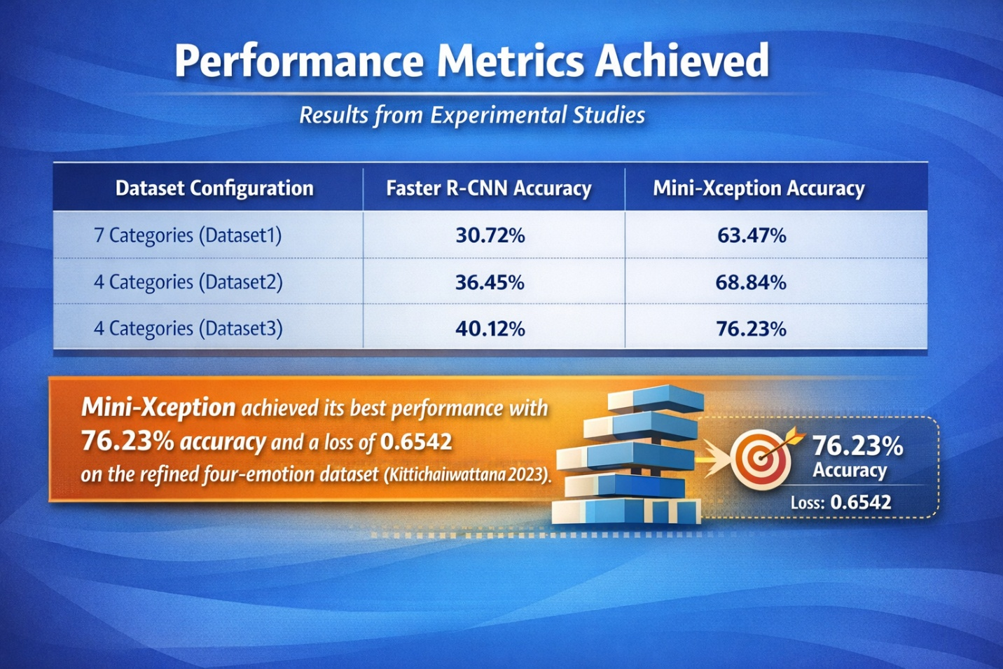
Limitations
- Poor bounding box performance: The Faster R-CNN model frequently generated inaccurate bounding boxes that did not properly fit faces, including background information that led to misclassification (Kittichaiwattana2023).
- Emotion ambiguity: The models struggled to distinguish between sad and neutral emotions due to their visual similarity (Kittichaiwattana2023).
- Real-time processing issues: The Faster R-CNN model faced difficulties when deployed in real-time workflows due to its classification inaccuracies (Kittichaiwattana2023).
- Dataset limitations: The study had to remove significant portions of the original dataset due to duplicate images, non-face images, and ambiguous expressions (Kittichaiwattana2023).

Relation to Proposed Project
This paper provides valuable insights into model selection for facial expression recognition. The comparison between Faster R-CNN and mini-Xception demonstrates that for emotion recognition tasks, dedicated classification architectures may outperform detection-based methods. The finding that ambiguous emotions pose significant challenges informs our project's need for robust feature extraction and potentially larger, more diverse training data. The preprocessing approach of filtering ambiguous images could be relevant for ensuring dataset quality in our proposed system (Kittichaiwattana2023).
Paper 2: Bukhari et al. - A Deep Learning-based Framework for Emotion Recognition using Facial Expression
Problem Addressed
This research addresses the challenge of avoiding traditional feature extraction methods by leveraging deep learning models as automatic feature extractors for emotion detection. The authors highlight that while traditional methods require manual feature engineering, deep learning can automatically learn relevant features from facial images. The study also addresses limitations of standard CNNs, including long training times, catastrophic forgetting, vulnerability to adversarial inputs, and inability to handle cross-domain boundary areas (Bukhari2022).
Preprocessing Techniques
The study utilized two datasets:
- FER-2013: 32,298 grayscale images (48×48 pixels) with 7 emotion classes
- Cohn-Kanade (CK+): 293 video series with 640×490 or 640×480 pixel resolution
The preprocessing approach included:
- Resizing grayscale images to target dimensions
- Using Local Binary Pattern images and Interlaced Derivative Pattern images alongside grayscale images in the 3D CNN framework
- Data augmentation through the Image Data Generator in Keras for automatic labeling of emotion classes (Bukhari2022)

Model/Algorithm Applied
The researchers implemented four deep learning architectures:
- Custom CNN: A feed-forward artificial neural network with convolutional layers, pooling layers , flatten layer, and fully connected layers for classification (Bukhari2022).
- ResNet-50: A 50-layer deep residual network with five phases containing identity and convolution blocks. The model was trained on 22,972 training images, 5,741 validation images, and 7,208 test images across 50 epochs with input size 224×224×3 (Bukhari2022).
- VGG-16: An architecture featuring 3×3 filters with stride 1, same padding, and 2×2 max pooling layers with stride 2. The model includes two fully connected layers followed by softmax output, with 138 million parameters (Bukhari2022).
- Inception-V3: A 50-layer deep convolutional neural network pre-trained on ImageNet, with input size 299×299 pixels (Bukhari2022).
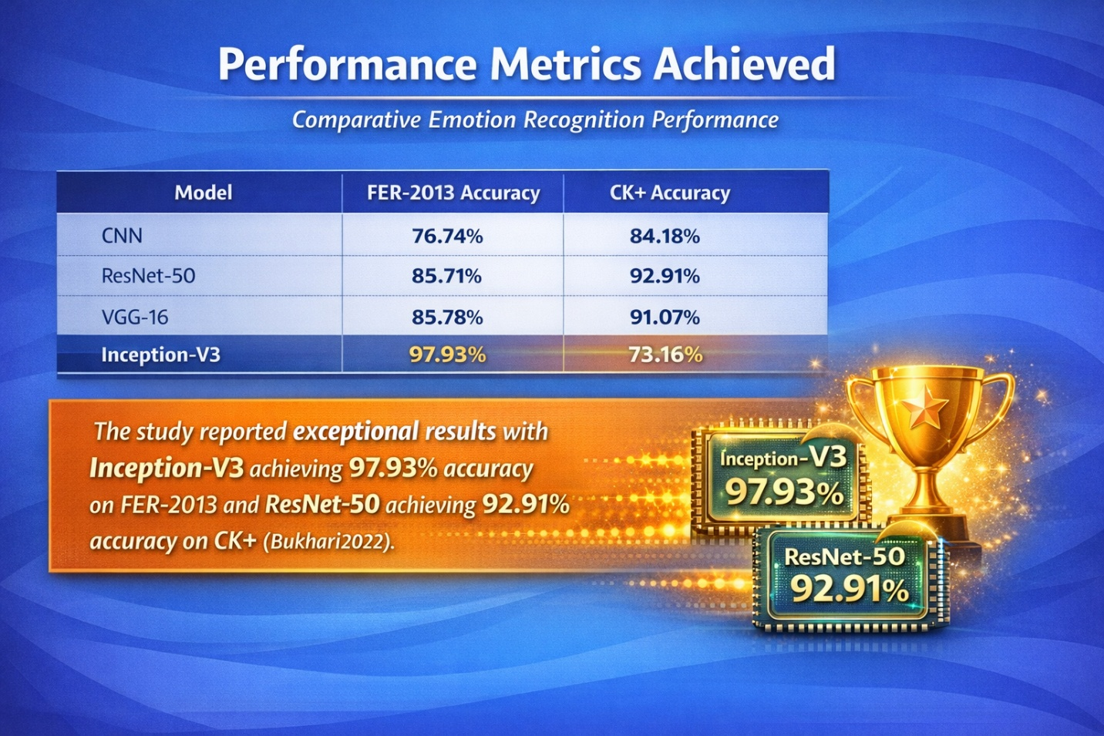

Limitations
- Cross-dataset performance variation: Inception-V3 performed exceptionally well on FER-2013 but poorly on CK+ (73.16%), while ResNet-50 showed the opposite pattern (Bukhari2022).
- Deep learning vulnerabilities: The authors acknowledge that deep learning models remain vulnerable to adversarial inputs and cannot derive results in cross-domain boundary areas (Bukhari2022).
- Dataset dependency: The intelligence of these models depends heavily on training datasets and they cannot solve dynamically changing problems (Bukhari2022).
- Global generalization issues: Neural networks can produce wrong results from inaccurate or incomplete input data due to lack of global generalization (Bukhari2022).

Relation to Proposed Project
This paper demonstrates the power of transfer learning for facial expression recognition, showing that pre-trained models like Inception-V3 and ResNet-50 can achieve significantly higher accuracy than custom CNN architectures. The finding that different pre-trained models perform differently across datasets (Inception-V3 excels on FER-2013 while ResNet-50 excels on CK+) suggests that our proposed project should consider dataset characteristics when selecting backbone architectures. The use of confusion matrices for performance analysis provides a template for evaluating our model's performance across emotion categories. The robust preprocessing techniques combining LBP and IDP with grayscale images could inform our feature extraction pipeline (Bukhari2022).

Paper 3: Haq et al. - Enhanced Real-time Facial Expression Recognition Using Deep Learning
Problem Addressed
This research addresses the critical challenge of performance degradation when facial expression recognition models trained on controlled laboratory datasets are applied to real-world, uncontrolled environments. The authors identify that factors such as degraded image quality, occlusions, variable lighting conditions, and alterations in head pose significantly impact model performance in practical applications. The study aims to enhance recognition accuracy for real-time, lower-resolution images captured in unstructured environments like internet-sourced content (Haq2024).
Preprocessing Techniques
The study utilized two datasets:
- FER-2013: 28,000 training images, 3,500 development images, and 3,500 test images (48×48 grayscale)
- Random Dataset: 350 color and grayscale images across six emotional categories
The preprocessing methodology included:
- Data collection from various online sources including links and data repositories
- Classification of images into seven emotional states: anger, happiness, fear, disgust, neutrality, sadness, and surprise
- Dataset composition with specific numbers per class for both FER-2013 and Random datasets (Haq2024)

Model/Algorithm Applied
The researchers implemented MobileNet-V1, a convolutional neural network architecture developed by Google that uses depth-separable convolutions to significantly reduce the number of parameters. Key features include:
- Depth-wise separable convolutions (depth-wise convolution followed by point-wise convolution)
- 28 total layers when counting depth-wise and point-wise convolutions separately
- Width multiplier hyperparameter for adjusting network complexity
- Approximately 4.2 million parameters
- Input dimensions of 224×224×3
- Bounding boxes for highlighting facial regions where emotions are detected (Haq2024)
The model was evaluated against a manual subjective assessment method where humans classified images into emotional categories (Haq2024).
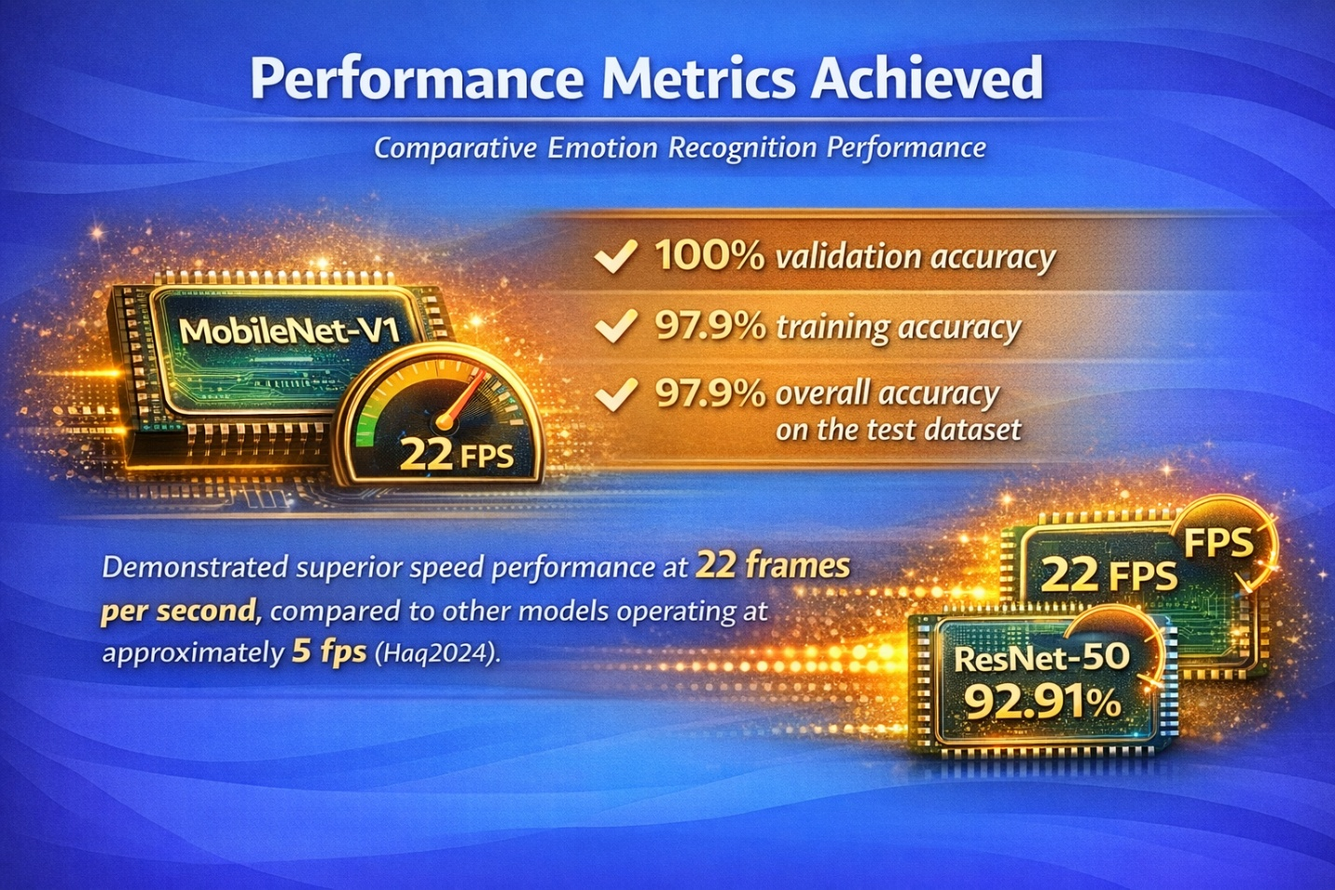
Limitations
- Emotional similarity confusion: The model struggled with visually similar emotions, misclassifying fear as surprise and disgust as sadness due to behavioral similarities in facial expressions (Haq2024).
- Real-world performance gap: Despite high training/validation accuracy, the model faced challenges with real-world images from various platforms (Haq2024).
- Subjective assessment discrepancies: Comparison with human judgment revealed that manual classification also suffers from uncertainty due to behavioral similarities in expressions (Haq2024).
- Ambiguity in infant expressions: Images of newborns were particularly challenging as expressions like fear could also be interpreted as surprise (Haq2024).

Relation to Proposed Project
This paper is highly relevant to our proposed project as it addresses the critical challenge of real-time deployment. The MobileNet architecture's efficiency (22 fps) and reduced parameter count (4.2 million) make it ideal for applications requiring real-time processing on resource-constrained devices. The comparative analysis showing MobileNet-V1's superior performance (97.9% accuracy) against more complex models demonstrates that efficiency need not compromise accuracy. The identification of emotion confusion patterns (fear/surprise, disgust/sadness) informs our project's need for addressing subtle emotional distinctions. The manual vs. model comparison methodology provides a framework for evaluating our system against human-level performance (Haq2024).

Comparison
Problem Focus Comparison
The three papers address complementary aspects of facial expression recognition. Kittichaiwattana et al. (Kittichaiwattana2023) focus on comparing detection-based (Faster R-CNN) versus classification-based (mini-Xception) approaches for basic emotion recognition. Bukhari et al. (Bukhari2022) emphasize transfer learning to avoid manual feature engineering and achieve high accuracy on benchmark datasets. Haq et al. (Haq2024) concentrate on real-world applicability, addressing the performance gap between laboratory and uncontrolled environments.
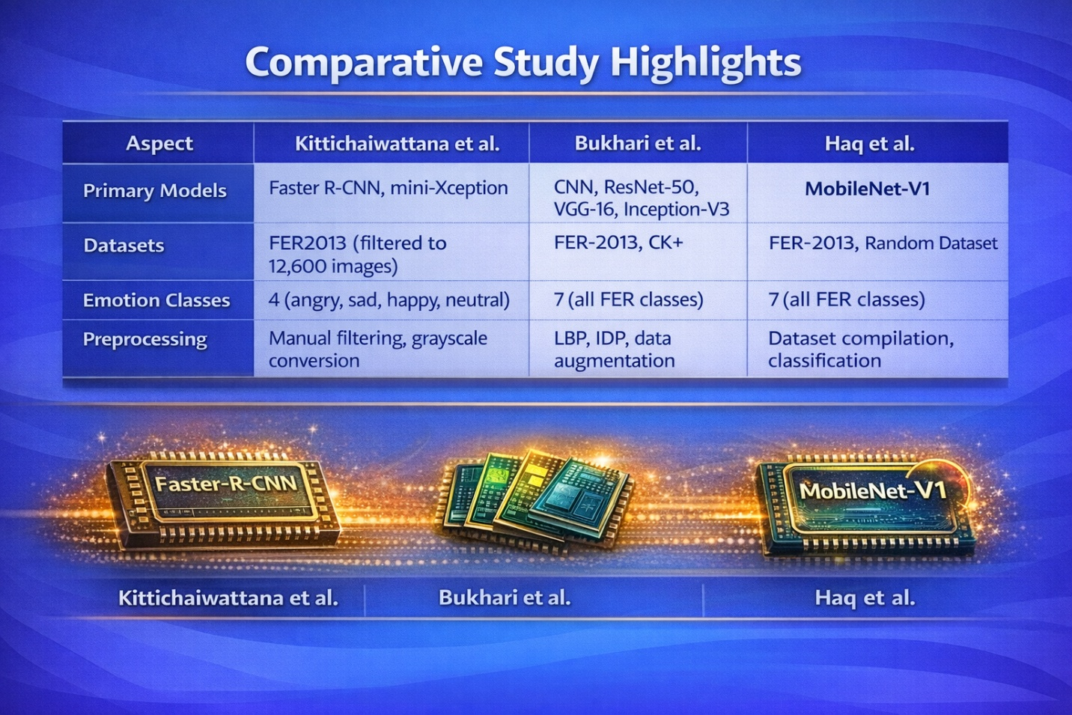
Common Limitations
All three papers identify similar challenges:
- Emotion ambiguity: Difficulty distinguishing between visually similar emotions (sad/neutral, fear/surprise, disgust/sadness)
- Dataset quality issues: Need for careful filtering and preprocessing
- Real-world generalization: Performance degradation when moving from controlled to uncontrolled environments

References
Bukhari, N., Hussain, S., Ayoub, M., Yu, Y., and Khan, A. "A deep learning-based framework for emotion recognition using facial expression." Pakistan Journal of Engineering and Technology, vol. 5, no. 4, 2022, pp. 1-7.
Haq, H. B. U., Akram, W., Irshad, M. N., Kosar, A., & Abid, M. (2024). Enhanced real-time facial expression recognition using deep learning. Acadlore Trans. Mach. Learn, 3(1), 24-35.
Kanjanawattana, S., Kittichaiwatthana, P., Srivisut, K., & Praneetpholkrang, P. (2023). Deep learning-based emotion recognition through facial expressions. Journal of Image and Graphics, 11(2), 140-145.

